* **SOFTWARE ENGINEERING ASSINGMANET**

**MODULE: -01**

**SE-OVERVIEW OF IT INDUSTRY**

**________________________________________________________________**

**Que-1 what is software? What is software engineering?**

**Ans: -**software is a set of instruction, data or programs used to operate computers execute specific task.

* **Software engineering:-**

1)software engineering is a technique through which we can developed or created software for computer systems and any other electronic device.

2)In other words, software engineering is a process in which user needs are analyzed and software is a designed based on their needs.

3)In software engineers the development. F software using well define scientific principal method and procedures.

4)software engineers build these software applications by using designing and programming languages.

**Que-2 Explain types of software?**

**Ans: -** there are 5 types of software.

(Application software, system software, driver software, middleware, programming software)

**1)application software: -**Application software is type of computer program that perform specific personal, educational and business function. Each application is ssit end-users in accomplishing a variety of tasks, which may be related to productivity, creativity or communication.

**2)system software: -**system software is a types of computer program That is designed to run a computer’s hardware and application programs. If we think of the computer system as a layered model, the system software is the between the hardware and user applications.

**3)driver software: -** Is a driver software is a types of software program that controls a hardware device. On any computer, smartphone, tablet, different hardware components that are part of the computer to function and work as well.

**4)middleware:** - middleware is software and cloud services that provide common service and capabilities to applications and help developers and operators build and deploy applications and help efficiently. Middleware acts like the connective tissue between applications, data and users.

**5)programming software:** - programming software is a tool for creating computer code that allows the computer software to operate. The computer technology field frequently uses overlapping terminology. Development is the actual design of the program, whereas programming is the execution of development instructions.

**Que: -3 what is SDLC methodology?**

**Ans: -** SDLC**-** software development life cycle.

* There is total 6 phases in SDLC methodology.

(Requirement gathering, Analysis, Designing, Implementation, Testing, Maintenance)

**1)Requirement gathering: -**An essential first step in acquiring an information system is requirements gathering. Requirement gathering is an exploratory process that involves researching and documenting a project’s requirement form start to finish.

**2)Analysis: -** feasibility analysis is the process by which feasibility is measured. The feasibility analysis in a project that a feasible at one point in time may become infeasible at a letter point in time.

**3)Designing:** - In SDLC, the design phase is a stage whare software development define the technical details of the product.

**4)implementation: -** This phase is initiated after the system has been tested and accepted by the user.

**5)Testing:** - once the developers build the software, them it deployed in the testing environment. Then the testing team tests the functionality of the entire system.

**6)Maintenance:** - the maintenance phase happens after the project team deploys the software and it’s fully operational in the customer environment.

**Que: - 4 what is DFD? Create a DFD diagram on Flipkart.**

**Ans:-** A data flow diagram (DFD) maps out the flow of information for any process or system. It uses defined symbols like rectangles, circles and arrows, plus short text labels, to show data inputs, outputs, storage points and the routes between each destination.

* **DFD diagram on Flipkart.**

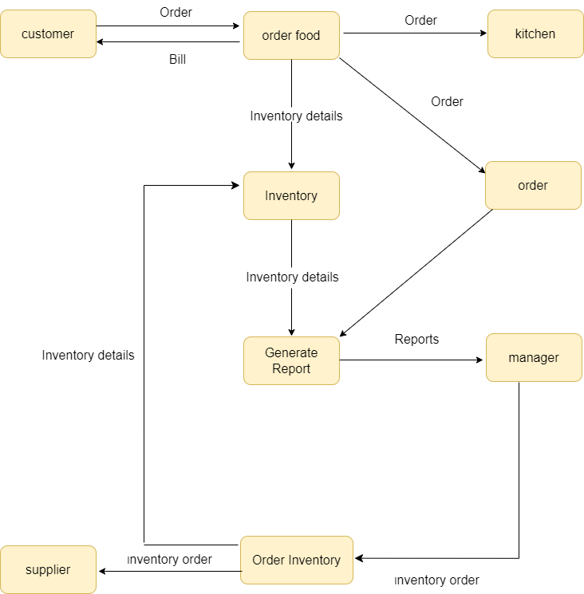

**Que: -5 what is Flow chart? Create a flowchart to make addition of two numbers.**

**Ans:-** A flowchart is a diagram that depicts a process, system or computer algorithm. they are widely used in multiple fields to document, study, plan improve and communicate often complex processes in clear, easy-to-understand diagrams.

* **Flowchart: ­**

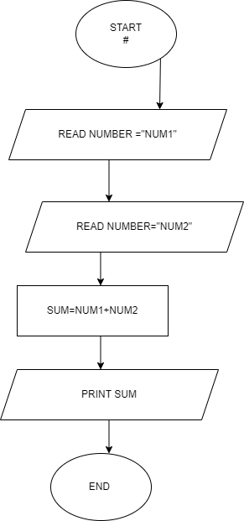

**Que: -6 what is Use case Diagram? Create a use-case on bill payment on paytm .**

**Ans:-** A use case diagram is a graphical depiction of a user's possible interactions with a system. A use case diagram shows various use cases and different types of users the system has and will often be accompanied by other types of diagrams as well. The use cases are represented by either circles or ellipses. The actors are often shown as stick figures.

* **Use–case on payment on paytm**

**­­­­­**



